ADVISORY NEIGHBORHOOD COMMISSION 6E
PO Box 93020 Brentwood Station, Washington, DC 20090

September 8, 2021

Anthony Hood
Chairman
Zoning Commission for the District of Columbia
441 4th Street NW
Washington, DC 20001

Re: Letter of support for 899-999 North Capitol Street NE- Zoning Case 21-09

Dear Chairman Hood:

Advisory Neighborhood Commission 6E conducted a virtual public meeting on Tuesday, July 6, 2021 and we were asked to consider the request for a letter of support for the design review for 899 and 999 North Capitol Street. NE. The property is in Advisory Neighborhood Commission 6C, but Advisory Neighborhood Commission 6E is across North Capitol Street. NE
The developer, Network Realty Partners, met with the Commission’s Zoning Committee. The Committee was overall very pleased with the future development and excited to have a more active streetscape but had two concerns:

- The massing on 999 North Capitol St. NE is somewhat darker than that on 899 North Capitol Street.
- The developer did a good job on making green space, but it is preferred that more green space be considered to enhance the pedestrian experience.

At the Commission’s meeting, duly noticed, with a quorum present (four out of seven Commissioners required to be in attendance to achieve a quorum), ANC 6E voted to support (6 in favor, 0 opposed, and 0 abstention) the Design Review Application for Zoning Case #21-09 of 899-999 North Capitol Street NE.
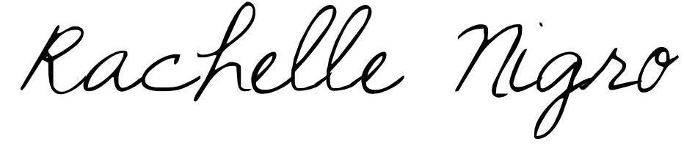
Respectfully submitted,
Rachelle Nigro
Chair
Advisory Neighborhood Commission 6E

