ANC 6E News
Representing Shaw, Mount Vernon Square, Mount Vernon Triangle, and NW One

We Are Family—Serving Senior Citizens in ANC 6E

We Are Family is a grass roots, volunteer driven, nutrition organization that not only feeds the bodies of seniors but also their spirits. Started in 2004, We Are Family originally grew from a tragic murder of a resident from the Sursum Corda area. Senior citizen leaders, who belonged to St. Aloysius church saw a need through that community crisis that low income seniors were at risk due to lack of means and information. To close this food and social service gap We Are Family originally partnered with the NW Settlement House, formally located on Ridge Street, and received initial funds of $15,000 from the musical group Good Charlotte.

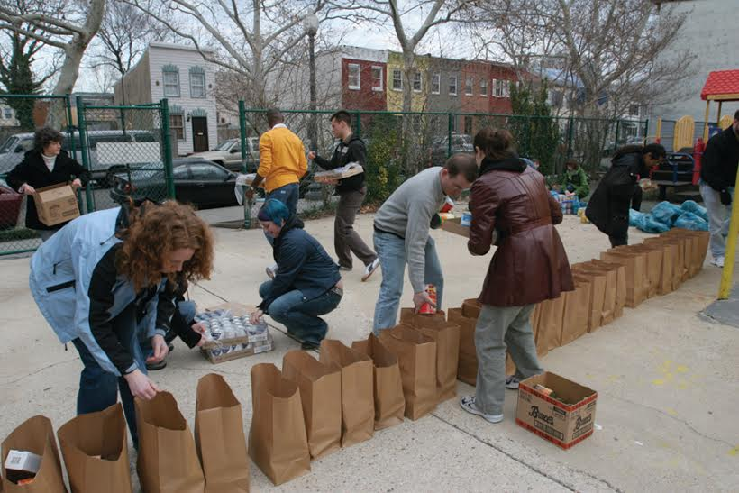
Currently one of their planning outposts is based at the Metropolitan Community Church on Ridge Street. Often volunteers can be seen organizing and bagging food donations in the church’s parking lot. Led by Co-Director Mark Anderson, he coordinates food delivery for over 600 seniors every month both in the Shaw and Columbia Heights areas. "The neighborhood is much more desirable and safer now for seniors. With that comes a more expensive neighborhood. The margin for survival for low income seniors is slim.” Anderson explained. Two main functions of the organization are friendly home visits on the second Saturday of every month and grocery deliveries on the third Saturday. By participating in the friendly visitor program clients not only receive emotional support and information about services they can use, but the visits help relieve loneliness. The monthly bag of groceries provides many needed basics that can often be financially out of reach for seniors. All services are free for clients which include many residents of Gibson Plaza, Lincoln West Moreland, Golden Rule and Ashbury Dwellings. In addition, We Are Family offers transportation services to appointments, advocacy with landlords, and emergency cleaning services. These services help seniors stay independent and give them the ability to live at home.

Nutritional resources come from the Capital Area Food Bank, food drives at community organizations and schools, and Federal commodity food programs. Anderson schedules more than 150 volunteers each month. The focus is on the senior citizen leadership giving back to the community. “Our foundation of neighbors looking out for other neighbors broadens our relationship within the neighborhood.” emphasizes Anderson.

If you would like to volunteer your time, make a donation or if you are need of the services of We Are Family please check out their website at www.wearefamilydc.org or call 202-487-8698.

Highlights from March’s Meeting

801-811 n street, nw: request for hprb approval
Michael Vallen, architect, stated that the property at 8th & N is currently a parking lot. The property is zoned C-2-A. They are proposing a five story L shaped building that fronts 8th & N Street with entrance on N. It will be an all residential building – 24 units: 23 are 2 bedrooms, 2 baths; and one (1) 1 bedroom and 1-1/2 bath. There will be two (2) lower levels of parking below ground and four (4) private roof top decks. The building size is 21,000 square feet total. There were concerns at the Zoning Committee meeting last week about ADA sensibility. ADA ramps will be added to the courtyard level and the first floor. There is a trash chute from the top to the bottom, bike parking, no zoning issues, no construction before 8:00 a.m., and they have a letters of support.
MOTION: Commissioner Wiggins moved and Commissioner Padro seconded that ANC 6E support the concept design of 801-811 N Street, NW and that said support be communicated in writing to the Historic Preservation Review Board (HPRB). The Motion passed unanimously, 6 yeas (Commissioners Wiggins, Padro, Maceda, Nigro, Chapple, Judd) – 1 nay (Commissioner Barnes) – 0 abstentions.
grand cata, 1550 7th street, nw: request for support for ABC Retailer’s class A license beverage sales permit
Andrew Kline, attorney, and Julio Robledo co-owner, of Grand Cata spoke on behalf of their request for support for an ABC Retailer’s Class A License Beverage Sales Permit. Grand Cata is a boutique wine shop featuring over 300 selections of wine.
MOTION: Commissioner Padro moved and Commissioner Nigro seconded that ANC 6E support the request of Grand Cata, 1550 7th Street, NW, for an ABC Retailer’s Class A License Beverage Sales Permit and that said support be communicated in writing to the ABC Board and ABRA. The Motion passed 5 yeas (Commissioners Nigro, Padro, Maceda, Chapple, and Wiggins) – 0 nays – 1 abstention (Commissioner Barnes).

Come out to the April Meeting!
The April meeting will take place at 6:30p.m. at the Shaw Library, 7th and R St. NW, on Tuesday, April 7th.
Agenda items will include:
- Presentation from DC 311 about the App.
- Public Space Support 425 I Street (outdoor café)
- Public Space Support 450 K Street (outdoor Café)
- Public Space Support 601 Mass Ave (Valet Parking)
- Zoning Relief Request Warren Group (O and 9th Street)
- Art Project -MVTCID ( Fence along 5th Street)

b Training Opportunity

ANC 6E Wants to Hear From You
Commissioner Contact Information
6E01 Commissioner Alexander M. Padro:padroanc@gmail.com, 202-518-3794
6E02 Commissioner Kevin L. Chapple:
chappleanc@aol.com, 202-449-5072
6E03 Commissioner Frank S. Wiggins:
wigginsanc6E@gmail.com, 202-658-1560
6E04 Commissioner Rachelle P. Nigro:
nigroanc6e@gmail.com, 202-670-1732
Twitter: @nigroanc6e
6E05 Commissioner Marge Maceda:
mmacedaANC6E05, 202-360-7404
6E06 Commissioner Antonio Barnes: antoniobar90@gmail.com, 202-200-1171
6E07 Commissioner Alfreda S. Judd: 202-628-6717

Social Media
Twitter: @anc6e
Facebook: Advisory Neighborhood Commission 6E
YouTube for Recorded Meetings: Search ANC 6E
Website: www.anc6e.org

It’s Potholepalooza Time!
DDOT is conducting their annual campaign to take care of all of those potholes.
Some ways to report a pothole to DDOT are:
*Call the Mayor’s Call Center at 311.
*Tweet DDOT at @DDOTDC. Use the hashtag #potholepalooza.
*Use the 311 Smart Phone App.

.

